PERFECTLY NORMAL FOR ME
<Film Festival name and date here>

Directed by award-winning filmmaker Catherine Tambini (HATE RISING, Sundance winner FARMINGVILLE, Emmy-nominated THE STATE OF ARIZONA, Academy Award-nominated SUZANNE FARRELL: ELUSIVE MUSE)

Produced by Elizabeth Hemmerdinger (Emmy Award winner THE HOMESTRETCH, ELAINE STRITCH: SHOOT ME, LOST AND SOUND, GOOD SISTER)

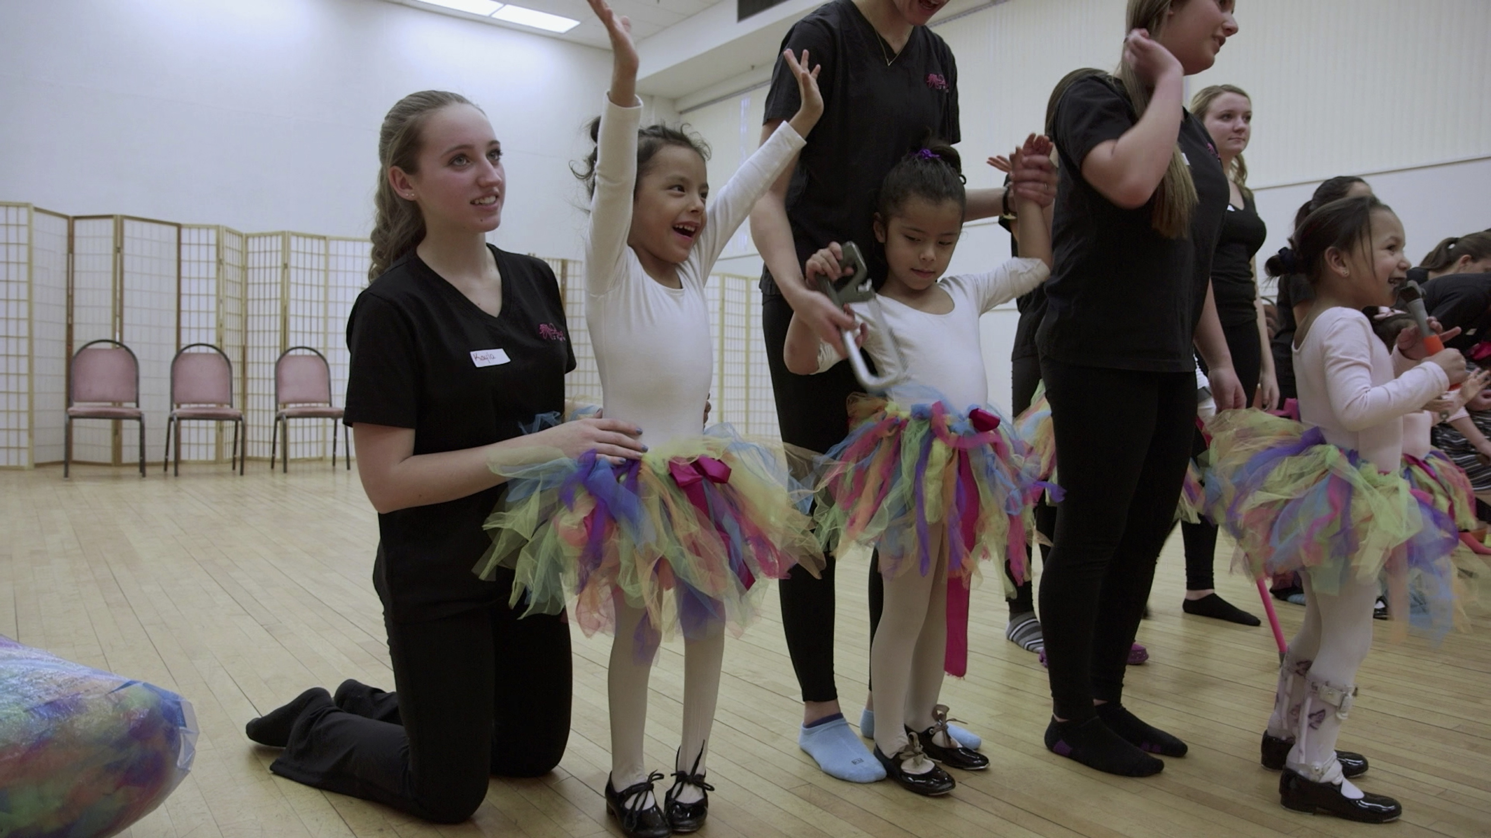

Alexandria, Jake, Caitlin and Veronica, ages 5 to 15, want to push the boundaries of their physical limitations. They reveal in their own words what it’s like to deal with the literal ups and downs of a challenged life. In this intimate verité documentary, four charismatic kids who we first meet at an after school dance program in Queens, NY strive for acceptance in a world that is often, at best, indifferent to them.

“In this film, both optimistic and realistic, the abilities of people with disabilities are brought to the forefront. The footage records their extraordinary will and the surprising grace they bring to an activity apparently antithetical to their physical condition….It is an important contribution to our understanding of ability, disability, and it challenges our narrow image of beauty. It is told with sincerity and with humor.” Andrew Solomon, author of Far from the Tree

Screeners are available upon request. Director Catherine Tambini and producer Elizabeth Hemmerdinger are available for interviews.

60 minutes
USA, 2017, in English
Director/Producer: Catherine Tambini
Producer: Elizabeth Hemmerdinger
Executive Producers: Laverne Berry, Sharon Hite
Directors of Photography: Matt Porwoll, Catherine Tambini
Editor: Emma Joan Morris

Official site: https://www.perfectlynormalformedoc.com/
Trailer: https://www.youtube.com/watch?v=cGR5hlocRjI
Facebook: https://www.facebook.com/perfectlynormalforme/

